**Traditional N-tier Web Application**

* This architecture provides zone redundant workloads for high availability with Three Layers for the application
  + Web
  + Business
  + Data (Relational)
* Architecture in Azure 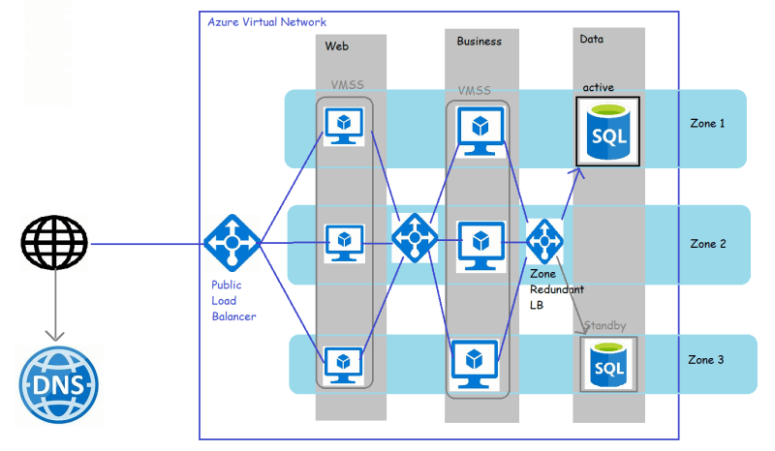
* Architecture in AWS 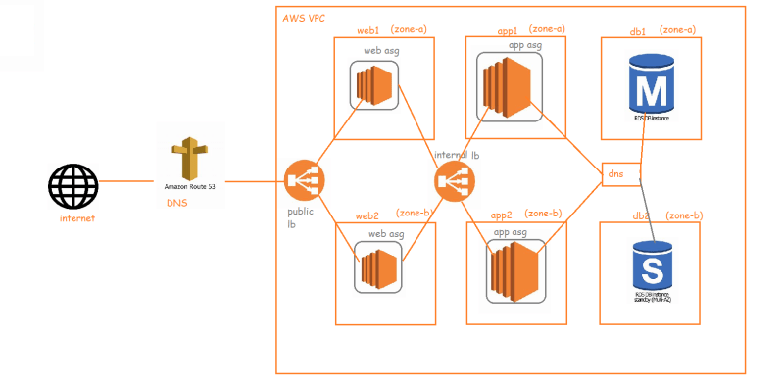

**Expanding this application to multi region**

* Azure 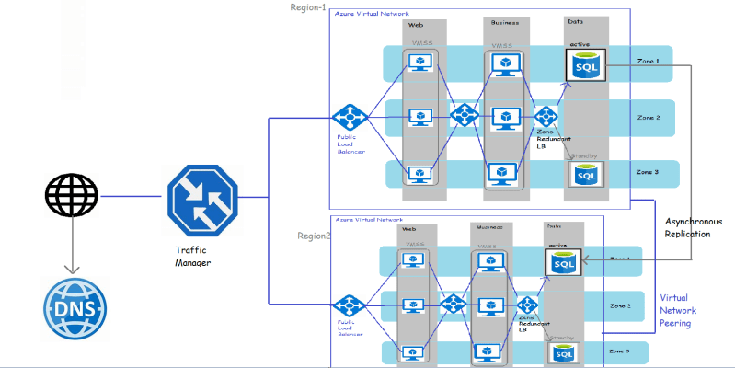
* AWS 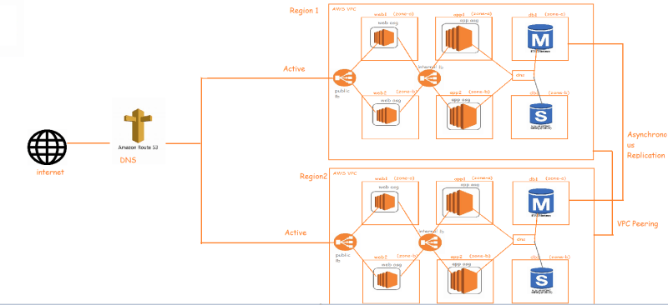

**Cloud Native Architectures**

* This is a design methodology where we utilize cloud services such as shown below to allow dynamic and agile application development techniques that take a modular approach to build, run & update software’s, through a suite of cloud-based microservices via traditional monolith or n-tier architectures
  + AWS: EC2, S3, lambda, Elastic Beanstalk
  + Azure: VM, Storage Account, Functions, App Services